1. Try with multiple catch

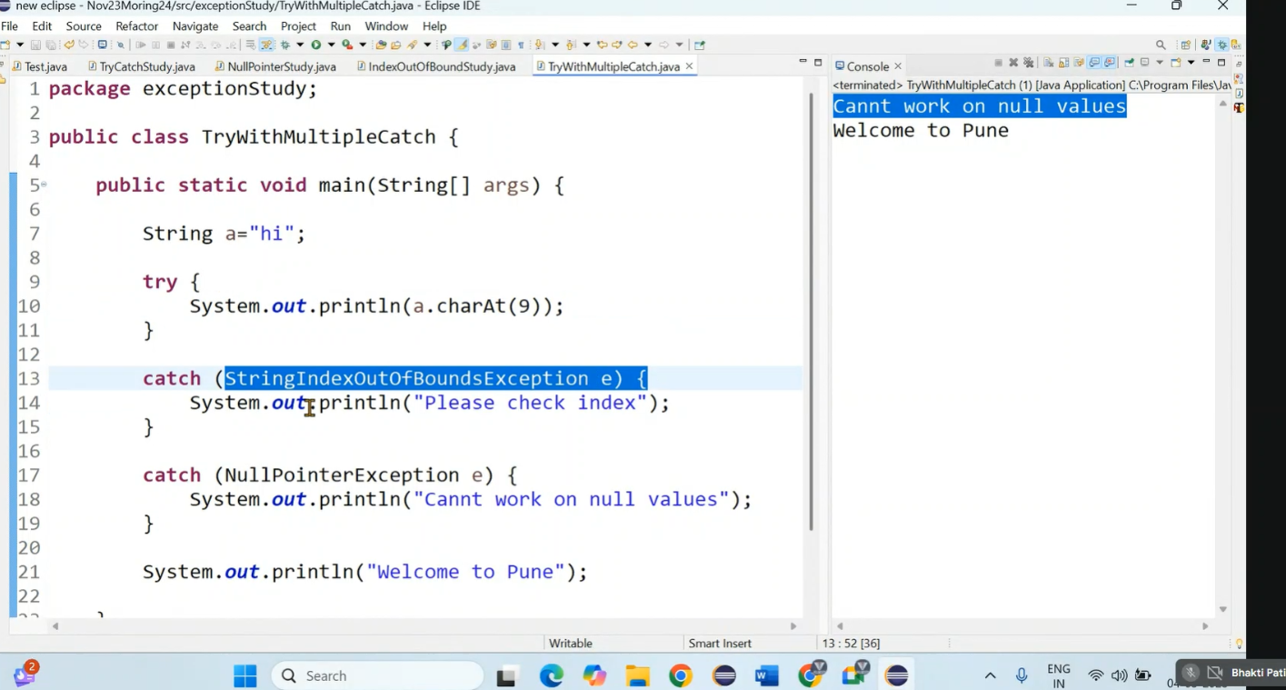

2. generic exception

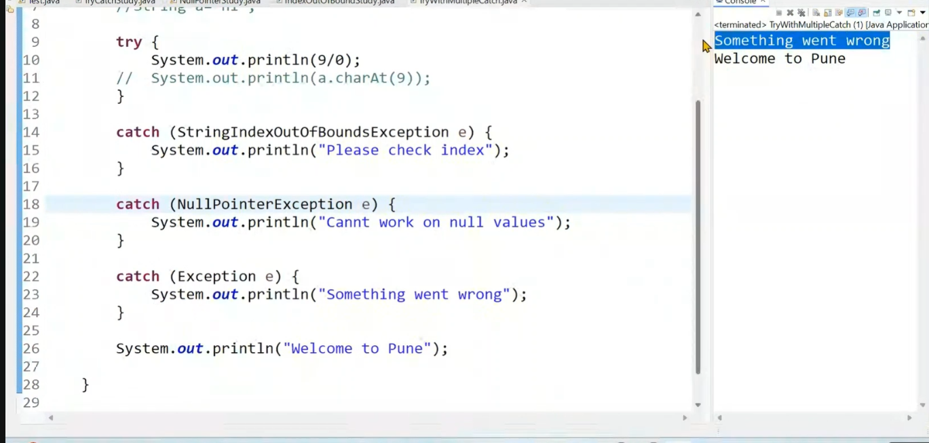

3. compile time error – because we used genric catch block at the begening.

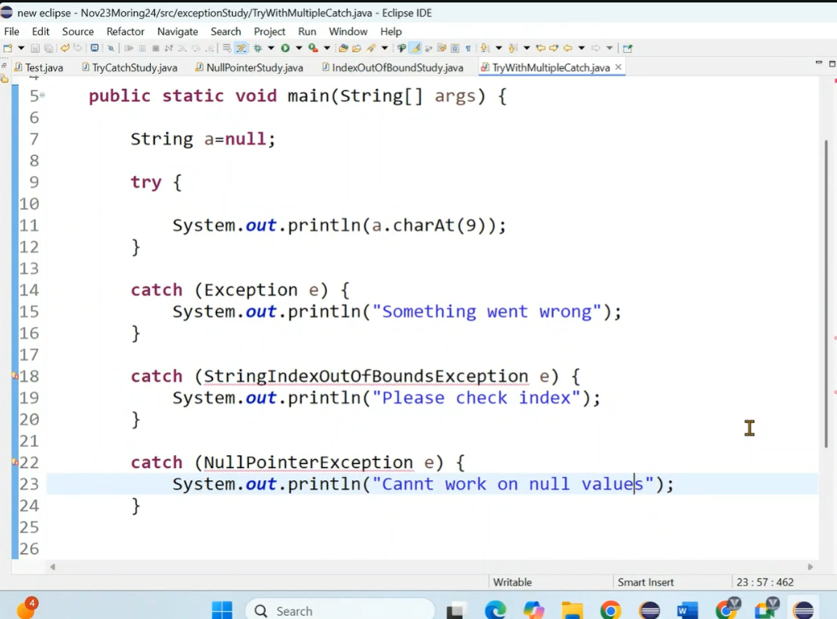

4. PrintStackTrace

If we use generic method at the begening it will handle all type of exception. But It will not show what type of exception it is. So use printStackTrace in generic block (line no 16). It will show particular exception.

e.getMessage – It is used to print msg(optional) . It will print what excactly happen.

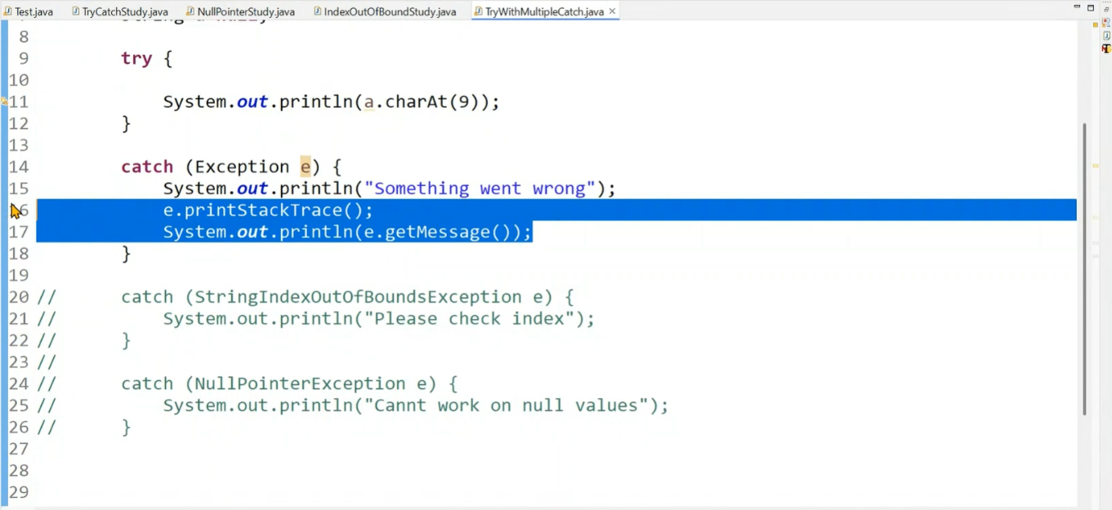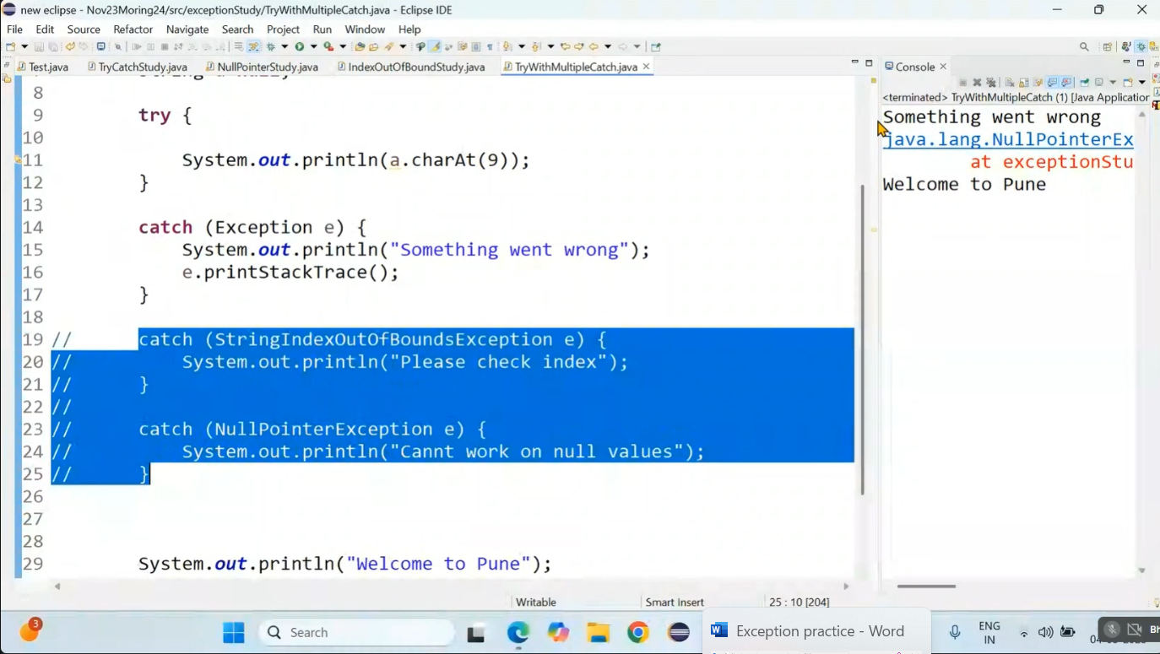

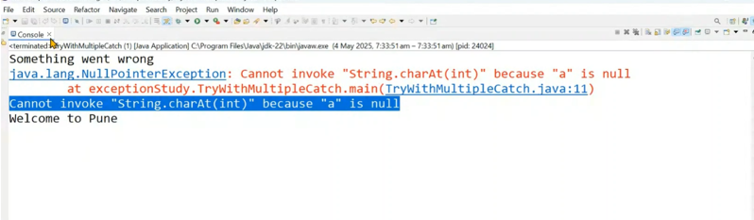

5. Try with Finally - It will execute in any condition

i. if try fails

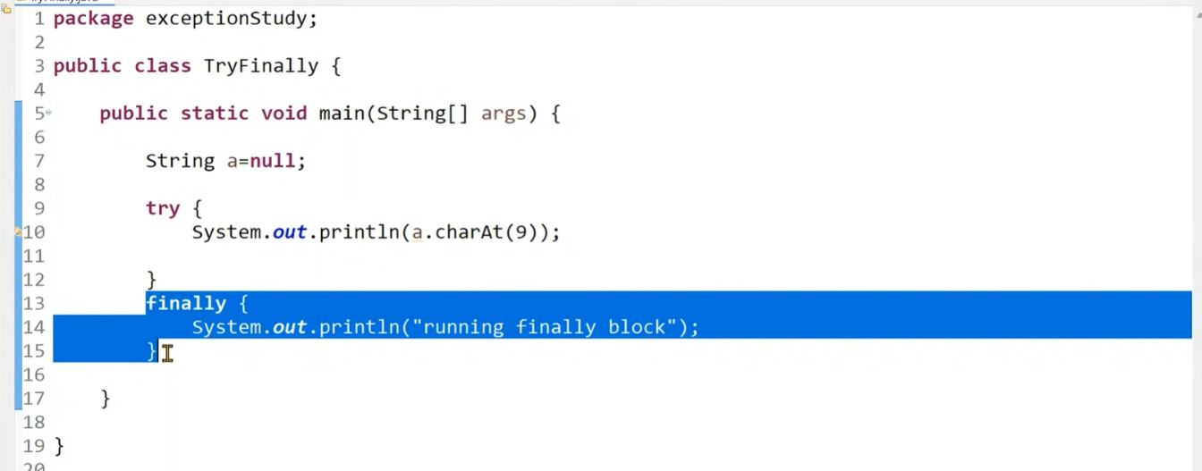

ii. if try block pass…finally block is also execute

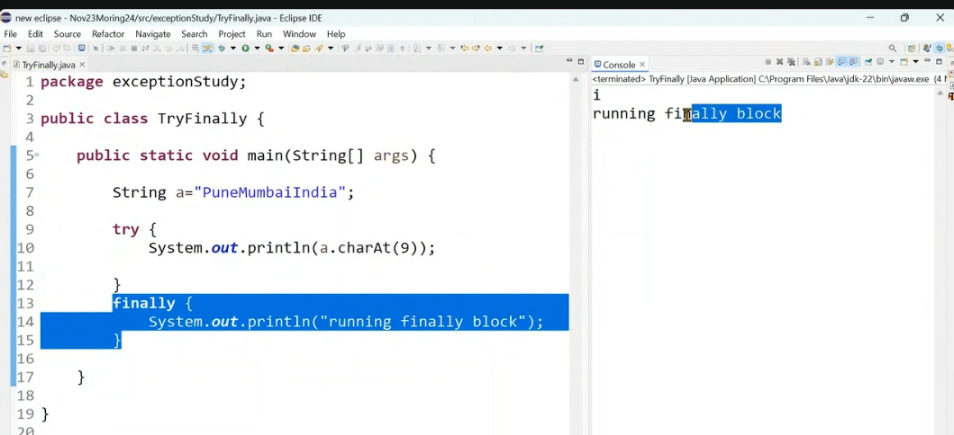

6. Try with catch and finally

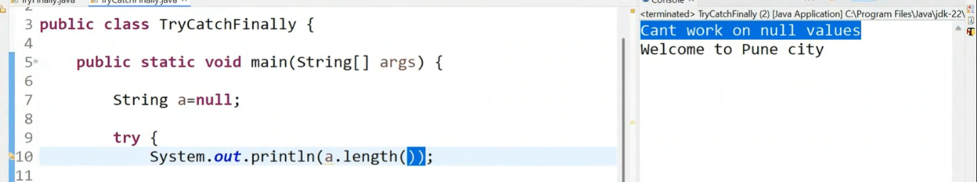

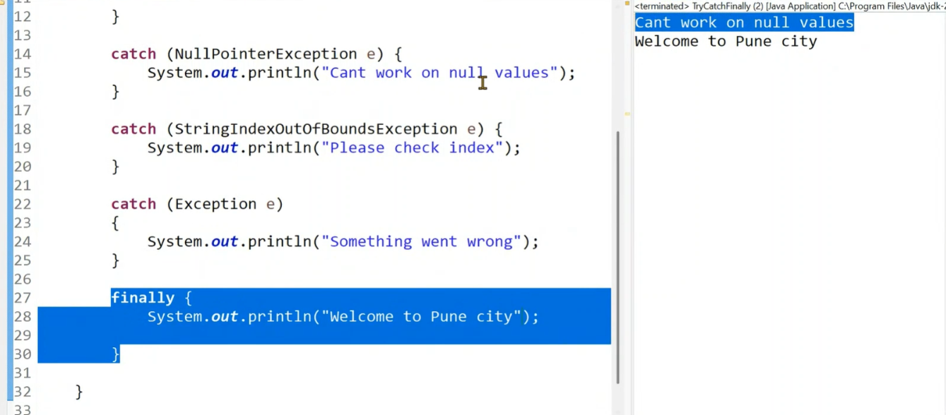

7. generic + finally

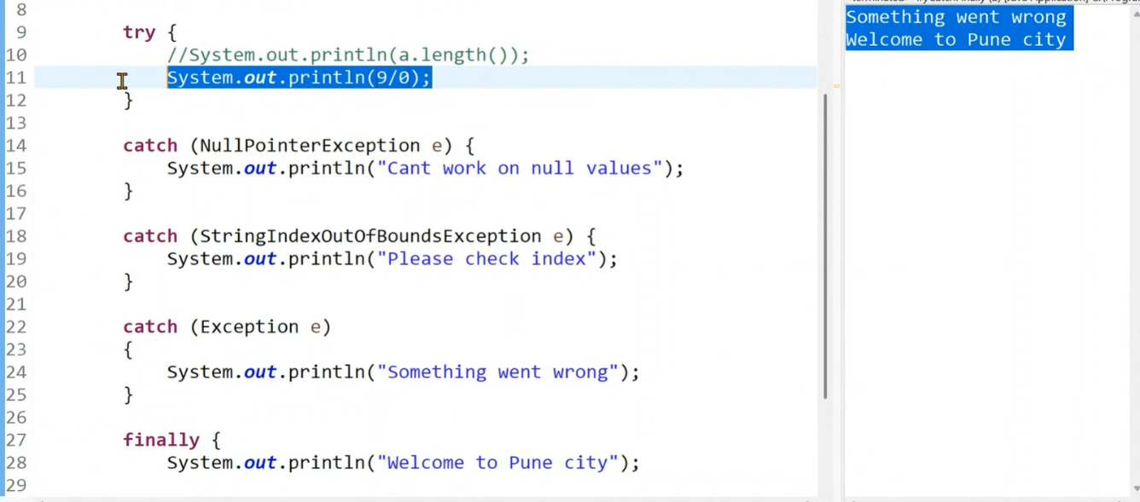

8. if both conditions true in try block

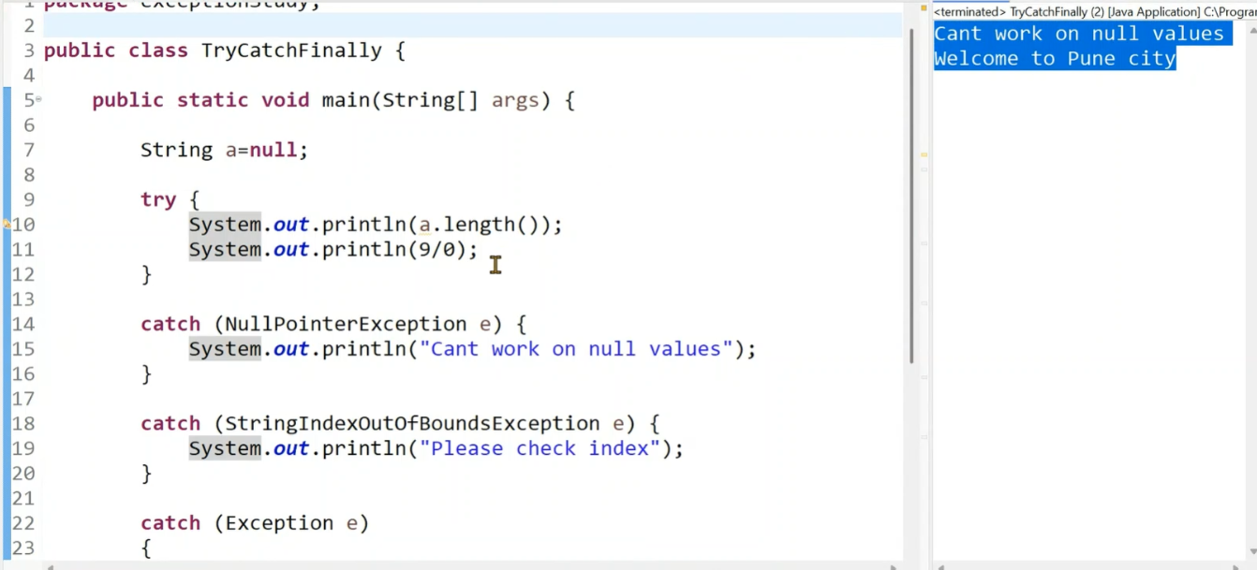

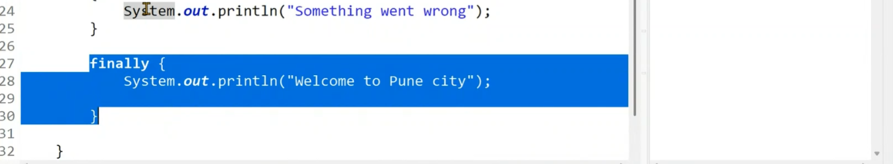

9. question

